Mini Project

Akash Paila (CS21B1017)

Sri Likhith (CS21B1034)

Under the Guidance of Mr. Dubacharla Gyaneshwar

Face Recognition Based Attendance System

horizontal line

ABSTRACT

In Today’s Digital era the management of attendance in various Institutions poses a significant challenge due to traditional paper-based methods being prone to errors, time-consuming and inefficient. To address these challenges, this project presents an automatic attendance system using face recognition.

The system begins by capturing the facial images using webcams or uploaded images, followed by pre-processing steps such as face detection and alignment. Subsequently the captured faces are compared with pre-existing face templates using a face-recognition algorithm, specifically Local Binary Patterns Histograms (LBPH). The recognition algorithm assigns labels to the detected faces enabling the platform to match the faces with corresponding identities in the attendance database. And at the end the attendance of recognized student will be marked in the excel sheet.

Overall, the automatic attendance based face recognition platform presented in this project offers a reliable and convenient solution for attendance management in educational institutions, corporate settings, and other organizations.

**Contents**

1. **Introduction**
2. **Related Works**
3. **Literature review**
4. **Methadology**
5. **Algorithms Used**
6. **Results**
7. **Future Scope**
8. **Conclusion**
9. **References**

**Introduction**

In recent years facial recognition technology has gained significant attention due to its potential for various applications in various industries. It is the technology that can identify or verify a person from a picture and now is being used more widely with the rise of devices like smartphones and CCTV cameras.

One area where it’s being applied is attendance tracking systems. These systems automate the process of takinga attendance which can be slow and prone to errors if done manually. In educational institutions attendance tracking is crucial part of daily classroom evaluation but teachers may miss students or record multiple entries. This is where facial recognition system comes into play. They compare the faces with the images which are stored in the database and mark the attendance automatically.

The aim of this paper is to introduce a advanced automated system for recording and tracking student attendance using biometric technology. The system makes the attendance quicker and more accurate compared to traditional methods.

Manual attendance systems require lecturers to collect, verify and manage student records, which can be time consuming, in contrast automated systems offers better benefits and reduce the workload for teaches.

**Related Works**

This paper explores existing attendance and monitoring tools used in various industries, most of which are automated but still prone to errors. It introduces a attendance system that integrates state-of-art methods and advancements in deep learning. By utilizing a smaller number of facial images and augmentation technique, this system achieves high accuracy.

Automated face recognition has transformed the attendance taking process make it more secure and efficient while reducing the reliance on paper and manual efforts.

As per the official documentation of opencv the currently available algorithms for face recognition are

1. Eigen Faces
2. Fischer Faces
3. Local Binary Patterns Histograms (LBPH)

The Eigen faces method emoploys mathematical transformations to derive facial features makes it less reliant on physical features of the face, however it is susceptible to lighting conditions and head position and the process of finding Eigen vectors and values are time consuming.

In Contrast the Fischer faces approach offers better classification of different image classes including facial expressions. Although more intricate than Eigen faces it is faster and more resilient to lightning conditions.

Whereas LBPH algorithm is very effective for face recognition. It operates by dividing the face image into smaller regions and extracting Local Binary Patterns from each region. LBPs encode the relationship between a pixel and its neighboring pixels capturing the texture information. These LBPs are then transformed into histograms representing the frequency of different patterns within each region. By comparing these histograms the algo can identify the similarities and differences between the faces enabling the accurate recognition even in the presence of variations in lighting and facial expressions and facial Orientation.

Thus LBPH offers a robust and computationally efficient approach to face recognition making it more suitable for real world applications.

**Literature Review**

**3.1 Individual Stable Space : An Approach to Face Recognition Under Uncontrolled Conditions**

According to the research Journal “ An approach to face recognition under uncontrolled conditions” (by Xin Geng) says that recognizing faces in everyday situations where the lighting, angle and other factors might vary a lot. This is called “ Face recognition under Uncontrolled conditions” Most face recognition systems works well only under controlled conditions but real life isn’t always like that.

The authors introduced something called “Individual Stable Space” which is a way to focus only on the important parts of the face for recognition, ignoring the distracting stuff like changes in lighting or facial expressions. The four main types of information in a face are Personal Characteristics (like what makes one person different from another person) , Common facial characteristics (Stuff all faces have) , Face status ( like changes in expressions or aging ) and Imaging configuration (things like lighting and camera angle). They figured out the way to extract the most important part - The Personal Characteristics using a technique called Linear Discriminant Analysis (LDA). Then they use this extracted information to develop algorithms that can recognize faces even in tricky, uncontrolled conditions.

These experiments shows that their approach works well even when the faces have lot of variations.

But the only drawback is that the system need image as input and one person per image which doesnt work if we need the attendance system from live feed.

**3.2 Face Recognition for Attendance Management System Using Multiple Sensors**

According to the research journal “ Face recognition for Attendance Management using Multiple Sensors ” by Dulyawit Prangchumpol says that Attendance management is crucial in educational institutions for ensuring accountability and monitoring student participation. Traditional methods like paper-based attendance sheets are labor-intensive and error-prone, leading to inefficiencies. Biometric techniques, such as fingerprint and facial recognition, have emerged as promising alternatives.

Fingerprint-based systems offer high accuracy but are invasive and require specialized hardware. Face recognition-based systems, leveraging deep learning and cascade classifiers, provide non-invasive and user-friendly authentication. However, challenges like varying lighting conditions affect accuracy.

Recent studies have focused on improving face recognition-based attendance systems. Techniques like Android Face Recognition with Deep Learning achieve recognition rates of up to 97%. Cloud-based storage enables real-time data synchronization, enhancing system efficiency.

In conclusion, while traditional methods have limitations, biometric technologies, particularly face recognition, offer significant potential for enhancing attendance management. Continued research and innovation are essential for overcoming challenges and developing robust, user-friendly solutions.

**Methadology**

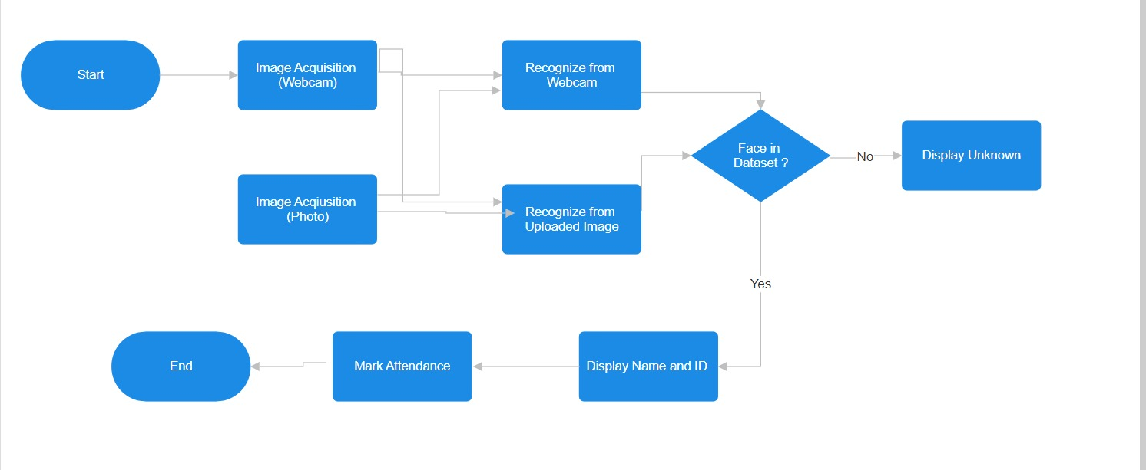

Here is the work flow of the running Model.

* Image Acquisition means collecting the data here our data is images of the students .
* Here it is done in 2 ways either by webcam or by the uploaded picture
* Here once we start the webcam the camera will collect the 100 images of the person and store it in separate folder for each person
* We also need to write the name and id of the person in the excel sheet
* Once the data gets collected then we need to train the model according to the data so that it will give results accurately according to the newly updated data.
* Second step is face recognition here we can recognize from webcam also we can recognize the faces by uploaded picture either the group pic or the single image
* If the person face is in dataset and his details are there in the excel sheet and if his face gets recognized then his name and id will be shown on the image of the person.
* Now here what we have implemented is of the “DURATION” in some cases some students left the class early or they will come at the time of the attendance marking so the minimum time they should be present then only their attendance will gets marked otherwill it will get marked as absent
* And the attendance will be visible in the excel sheet that gets created by that days date
* Also if some student leaves the college or school then there is a option called Delete face so that the face will gets deleted from the dataset by this we can save the memory/space.

**Algorithms Used**

1. **Haar-Cascade Classifier:**

Haar Cascade is a machine learning-based algorithm used to **detect objects** in images or videos. The algorithm uses a set of **Haar-like features**, which are rectangular patterns of pixel values, to distinguish between the object and the background. The algorithm trains a classifier using these features, which can then be used to detect objects in new images or videos.

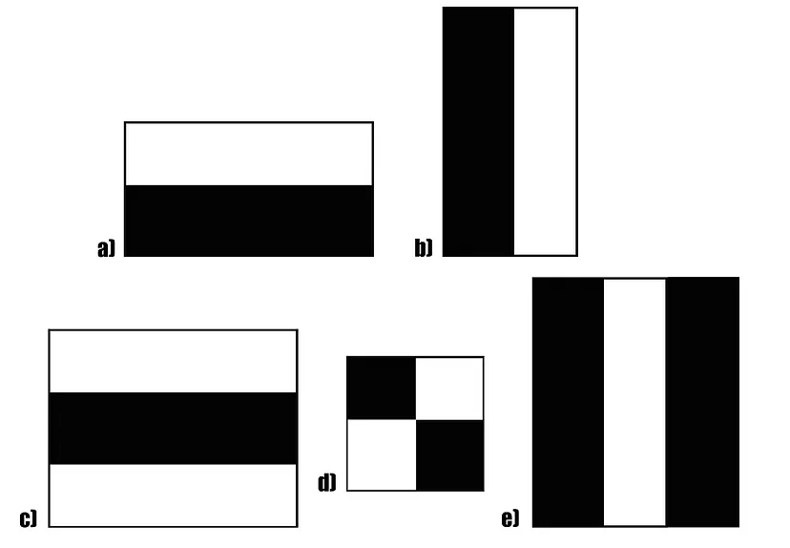

These are 5 Haar like features which are used for face detection.

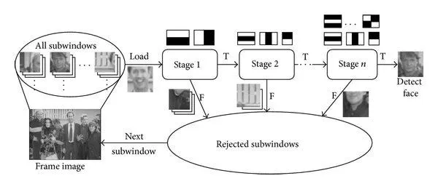

The classifier is then used to scan a new image or video for faces. The scanning process involves sliding a window of fixed size over the image and applying the classifier to each window. If the classifier detects a face in the window, it is marked as a potential face. The potential faces are then filtered based on their size, position, and shape.

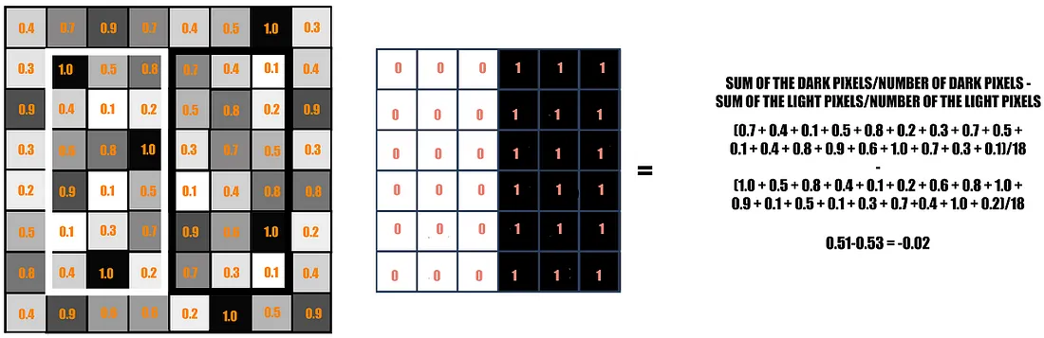

The objective here is to find out the sum of all the image pixels lying in the darker area of the haar feature and the sum of all the image pixels lying in the lighter area of the haar feature. And then find out their difference. Now if the image has an edge separating dark pixels on the right and light pixels on the left, then the haar value will be closer to 1. That means, we say that there is an edge detected if the haar value is closer to 1. Otherwise edge was not detected.

**2. Local Binary Patterns Histogram (LBPH) Algorithm :**

LBPH is a **Face-Recognition algorithm** that is used to recognize the face of a person. It is known for its performance and how it is able to recognize the face of a person from both the front face and side face.

LBPH uses 4 parameters:

* + Radius: The radius is used to build the circular local binary pattern.
  + Neighbours: The number of sample points to build the circular local binary pattern.
  + Grid X: The number of cells in the horizontal direction.
  + Grid Y: The number of cells in the vertical direction.

Local Binary Pattern (LBP) is a simple yet very efficient texture operator which labels the pixels of an image by thresholding the neighborhood of each pixel and considers the result as a binary number.

Applying LBP operations

* + The first computational step of the LBPH is to create an intermediate image that describes the original image in a better way, by highlighting the facial characteristics. To do so, the algorithm uses the parameters **radius and neighbours**.

Extracting the Histograms

* + Now, using the image generated in the last step, we can use the **Grid X and Grid Y** parameters to divide the image into multiple grids

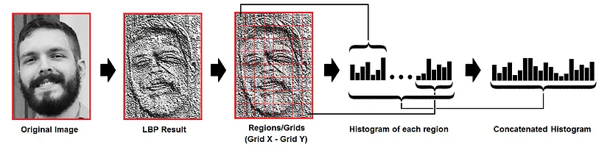

Based on the image above, we can extract the histogram of each region as follows:

* + As we have an image in grayscale, each histogram (from each grid) will contain only 256 positions (0~255) representing the occurrences of each pixel intensity.
  + Then, we need to concatenate each histogram to create a new and bigger histogram. Supposing we have 8x8 grids, we will have 8x8x256=16,384 positions in the final histogram. The final histogram represents the characteristics of the original image.

**Results**

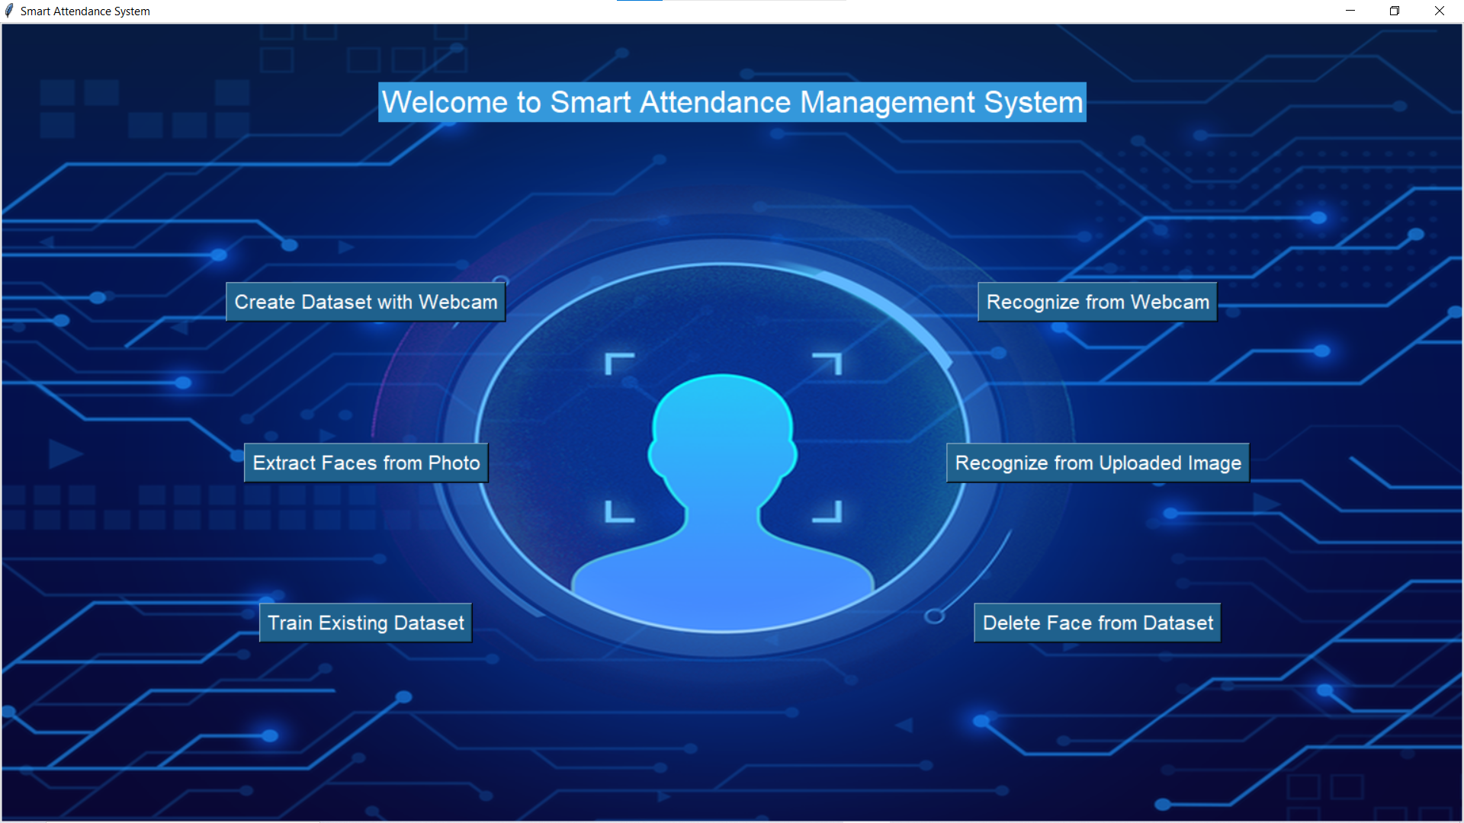

This is the Main page which was created using Tkinter GUI from Python.

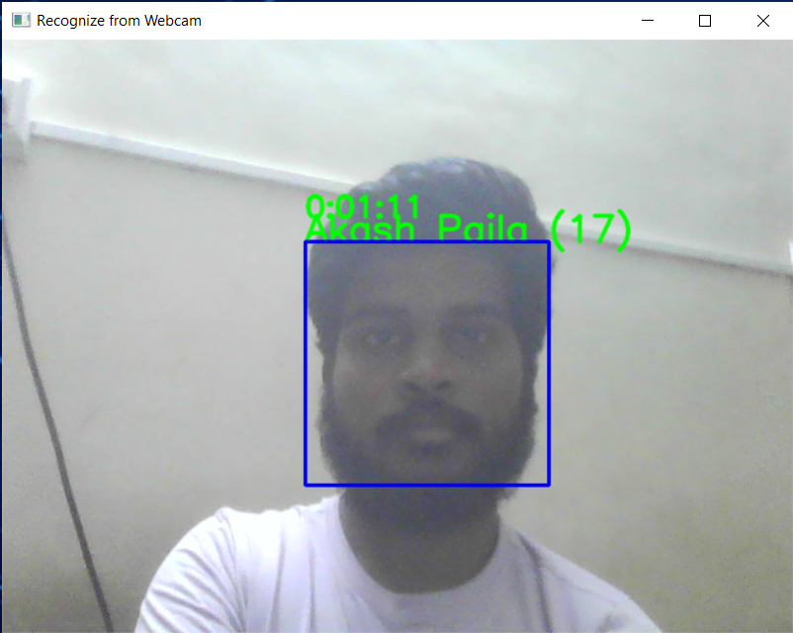

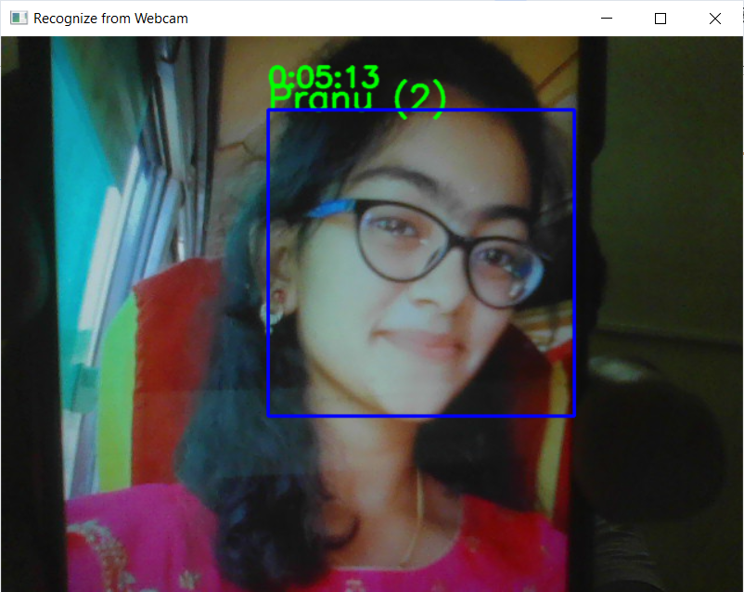

In the above 2 images single face is getting recognized and we can able to see the name of the student along with the id also we can see the duration

Also we can recognize multiple faces at a time

Now lets see the results of how it works if we upload the picture

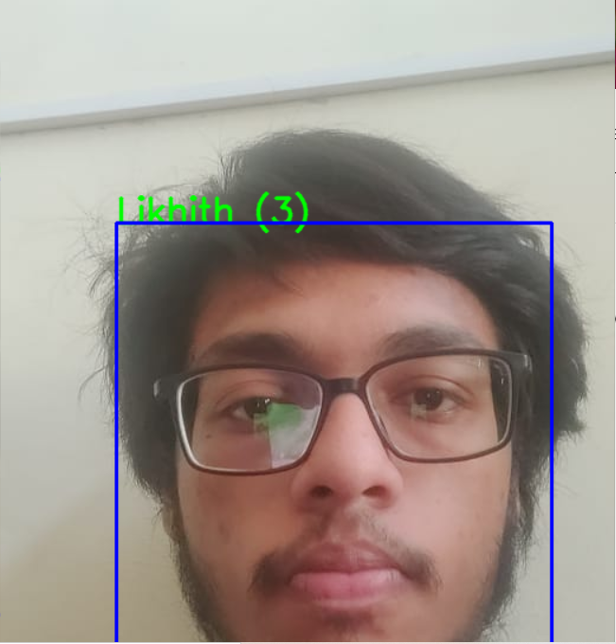

It also displays the name and id if we upload the picture of the person.

**Future scope**

1. Database Integration
2. Voice commands
3. Customizable UI Themes
4. Anti Spoofing

We have done a small implementation of Anti-spoofing Technique.

**Why is this Anti-Spoofing ?**

Here Some of them can try to fake the attendance by just showing the image of the other student even he was not there in the class.

So What we have implemented is **Blink Detection** using “Eye Aspect Ratio” (EAR).

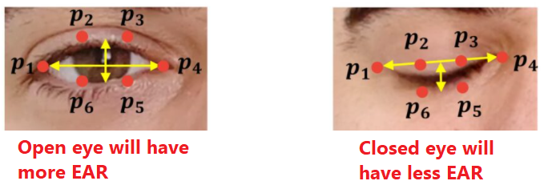

So by using this we can say weather the person is there in the class or not

**Conclusion**

The development and implementation of the smart attendance system have demonstrated the feasibility and effectiveness of leveraging computer vision and machine learning techniques to automate the attendance tracking process. Through the utilization of face recognition technology, the system offers a convenient and reliable method for accurately identifying and recording an individual’s attendance. Moving forward, the smart attendance system presents numerous opportunities for further innovation and application. Future enhancements may include the integration of advanced analytics for attendance pattern analysis and interoperability with other biometric authentication modalities. In conclusion, the smart attendance system represents a significant advancement in attendance management technology, offering a robust, efficient, and user-friendly solution for organizations seeking to optimize their attendance tracking processes.

**References**

1. <https://towardsdatascience.com/face-detection-with-haar-cascade-727f68dafd08>
2. <https://towardsdatascience.com/face-recognition-how-lbph-works-90ec258c3d6b>
3. <https://pyimagesearch.com/2017/04/24/eye-blink-detection-opencv-python-dlib/>
4. <https://www.geeksforgeeks.org/eye-blink-detection-with-opencv-python-and-dlib/>
5. Geng X, Zhou ZH, Smith-Miles K. Individual stable space: an approach to face recognition under uncontrolled conditions. IEEE Trans Neural Netw. 2008 Aug;19(8):1354-68. doi: 10.1109/TNN.2008.2000275. PMID: 18701367.
6. Roshan Tharanga J G *Smart Attendance using Real Time Face Recognition (SMART-FR) Department of Electronic and Computer Engineering* (Malabe Sri Lanka: Sri Lanka Institute of Information Technology (SLIIT))
7. Masalha F and Nael H 2014 A Students Attendance System Using QR Code *International Journal of Advanced Computer Science and Applications*